Safety:
All safety glasses and appropriate safety apparel is to be worn at all times. This includes wearing the appropriate protection for working at heights above six feet.

Purpose:
To outline steps necessary to complete the monthly preventive maintenance checks on the Mud Conveyor located in the Filter Press Room.
Procedure:
This Preventive Maintenance and/or Repair procedure should be conducted only if it can be performed without interrupting production. If some issue needs to be addressed that requires the system to be halted for any reason then the lead operator should be notified and allowed to take the equipment out of production before work begins.
- Starting at the lower end of the mud conveyor located under the Filter Press(s) grease both bearings controlling the lower end of the belt conveyor. Visually inspect ground anchors for proper attachment and housing to ensure that it is in proper working order.
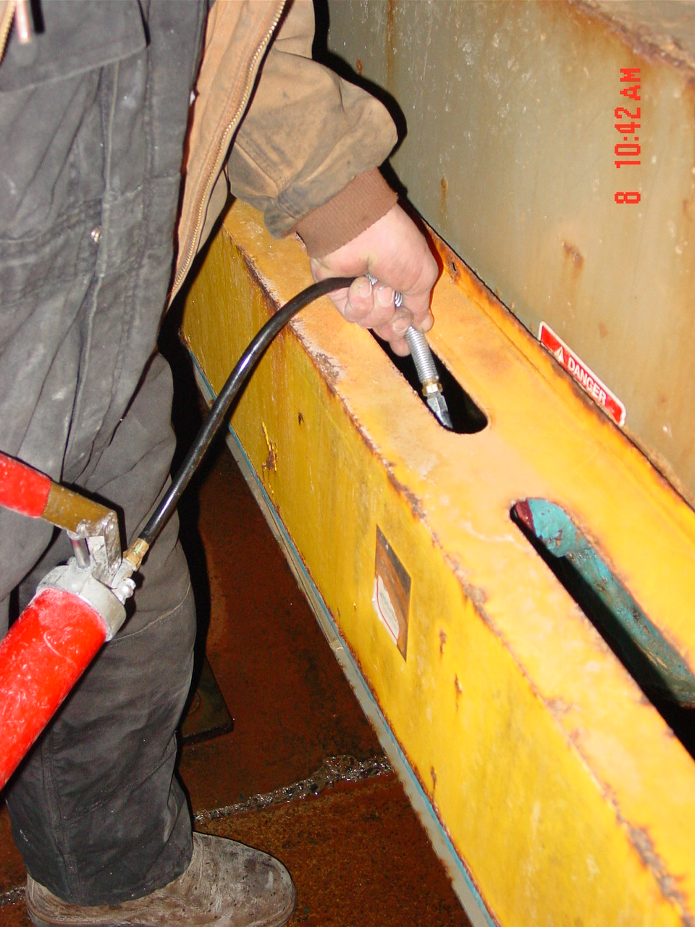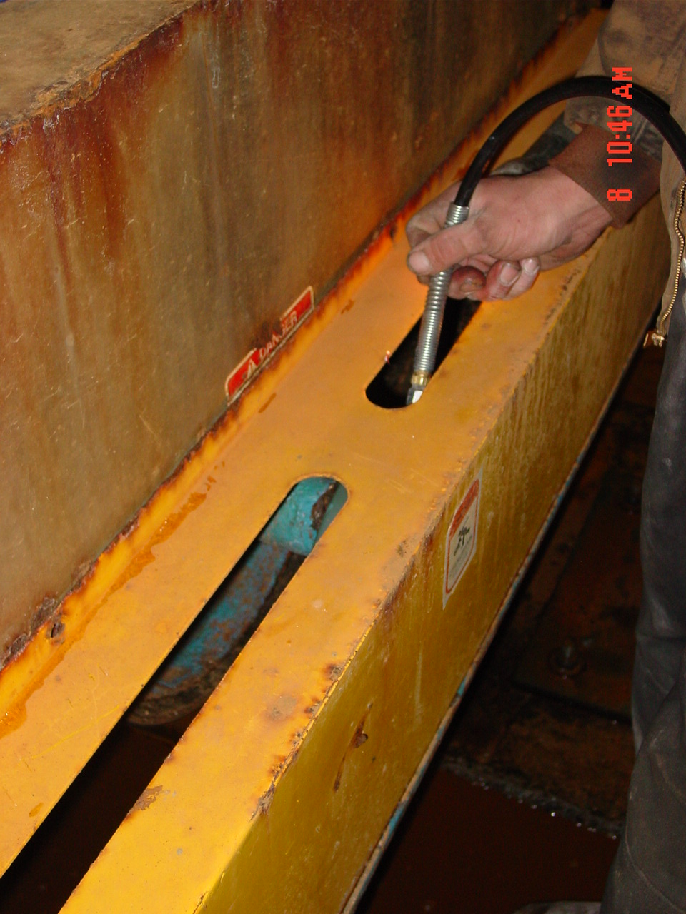

- Halfway up the mud conveyor but outside the building there is located two more grease fittings that require grease. Also visually inspect the rollers, belting, etc for any signs of required maintenance. (Two grease fitting connections at this location)
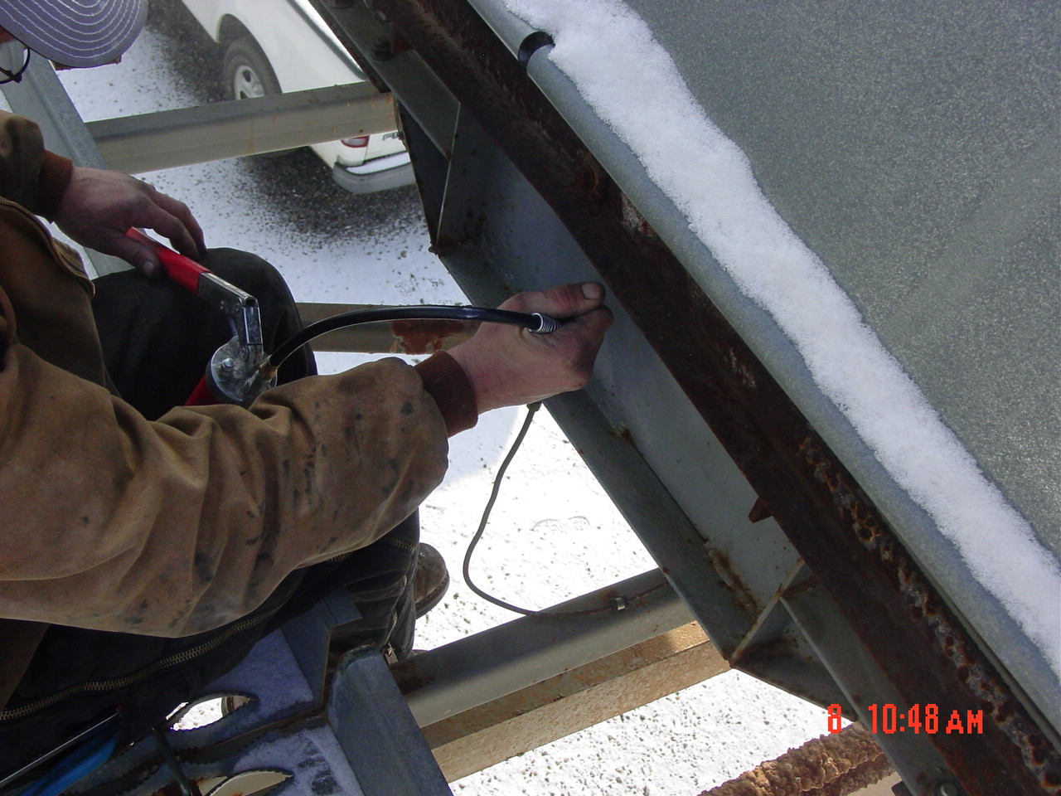
- When greasing on the drive end of the conveyor ensure that conveyor is in the off position and can not be operational. Grease, lube, and inspect gearbox, motor, and shaft of mud conveyor.
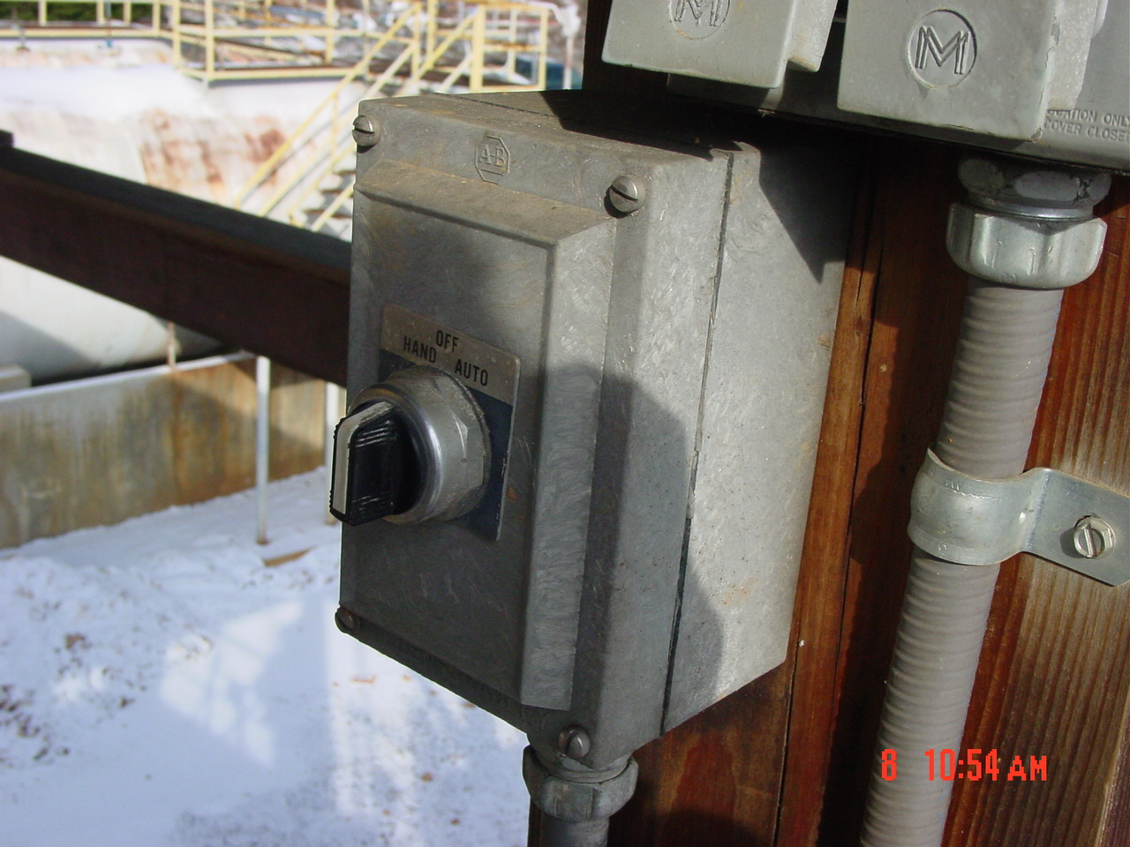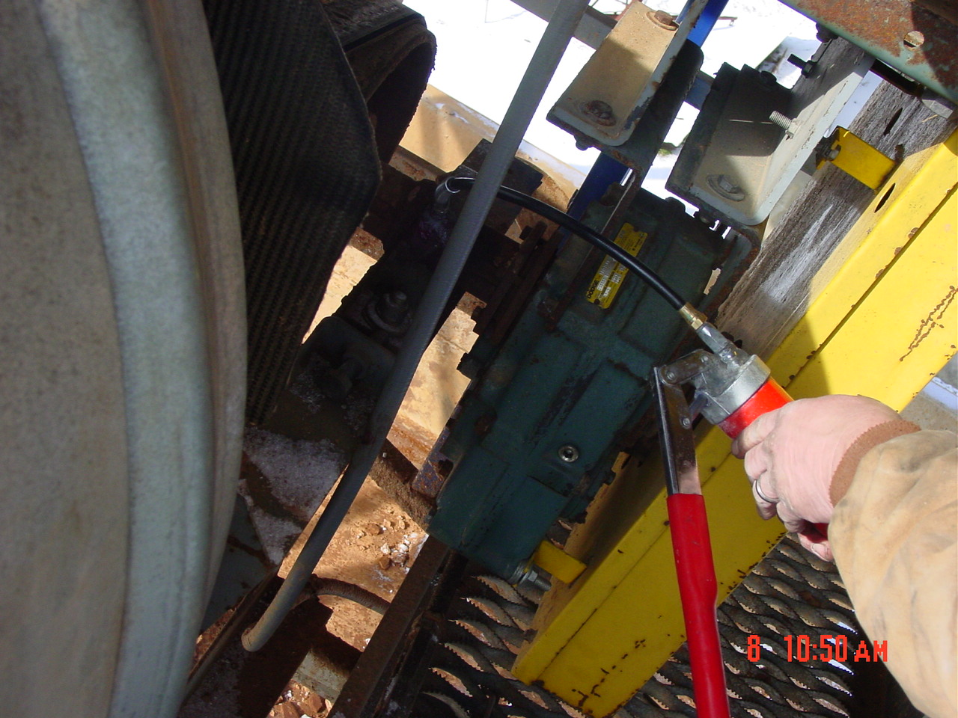

- Visually confirm gear box oil levels are ok and visually inspect belt scraper is operating properly. If adjustment is required clean and adjust.
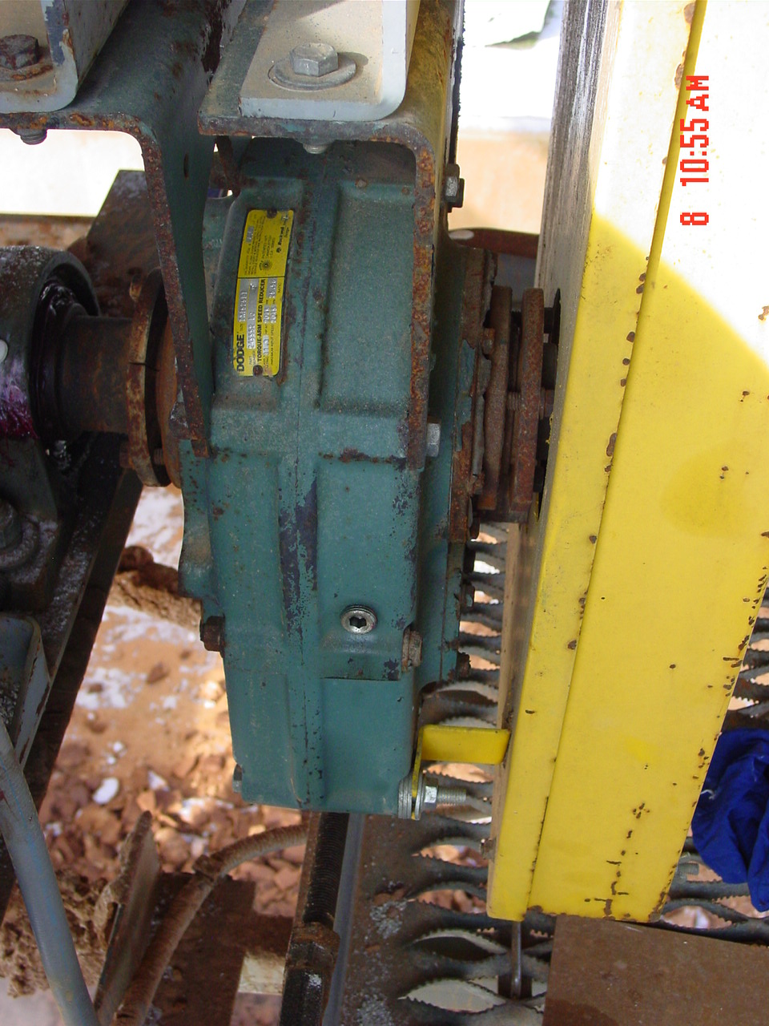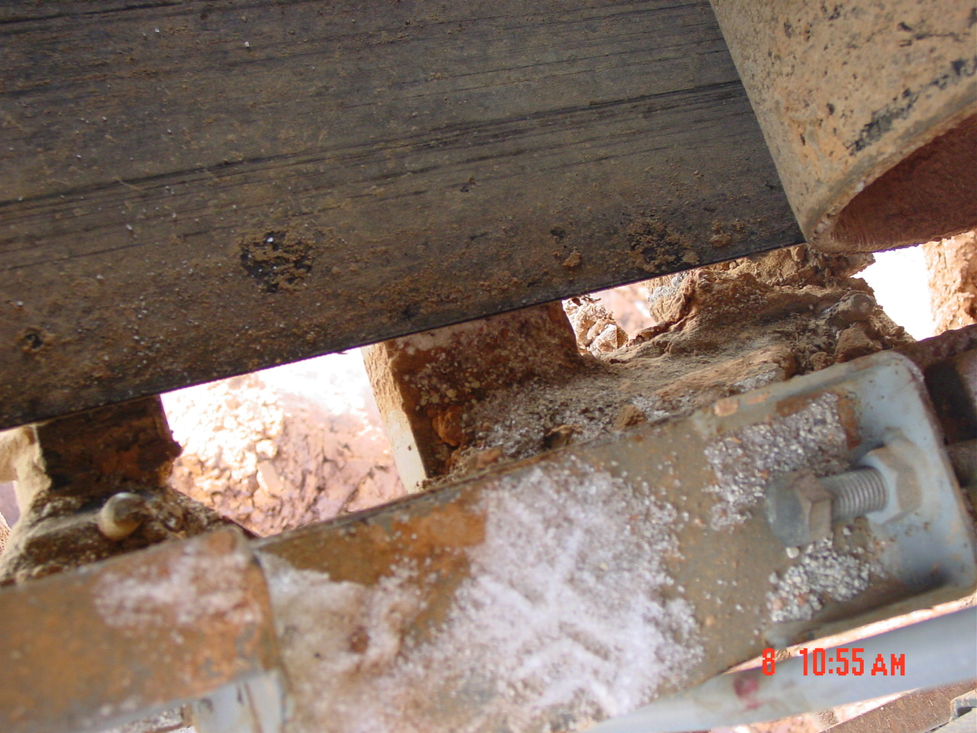
- Visually check all lighting on walkway to confirm it is operating properly.

TRAINING DOCUMENTATION

 | EMPLOYEE | TITLE | SIGNATURE | DATE
1
2
3
4
5
6
7
8
9
10
11
12
13
14
15
16
17
18

Revision  Number | Revision  Date | Revision  Author | Revision Description
00 | 1/12/09 | RW/JC | New Document

